TASK 1: BUSINESS INSIGHTS REPORT
Intern Name: Reddyvari Supraja
Submission Date: July 10, 2026
Company: Maincrafts Technology

1. Executive Summary
This report presents the foundational data analysis, data cleaning, and business intelligence extraction performed on the Superstore Sales Dataset. The objective of this analysis is to transform raw operational logs into clear, actionable business insights regarding regional performance, product profitability, and discount strategies.

2. Data Cleaning & Transformation Summary (Excel)
The raw dataset was audited and refined using Microsoft Excel to ensure reporting accuracy. The following operations were successfully executed:
- Duplicate Removal: Identified and removed 20 duplicate rows.
- Missing Value Treatment: Handled blank cells within critical fields using logical defaults.
- Format Standardization: Converted all date columns into a standardized YYYY-MM-DD format.
- Text Normalization: Corrected inconsistent naming conventions and regional spelling errors
- Output File Saved As: cleaned_sales_data.xlsx

3. Core Business Summary Metrics
Using Excel formulas (SUM, AVERAGE, COUNT) and Pivot Tables, the following high-level performance indicators were established:
- Total Sales Revenue: $125881.27
- Total Net Profit: $ 32683.35
- Total Orders Processed: 1893
- Average Sales: $ 261.7074
- Maximum Sales: $8159.952
4. Structured Data Extraction (SQL Queries)
The cleaned data was imported into a relational database structure. The following essential analytical queries were executed to prepare data for dashboard ingestion:

Query 1: Total Sales by Region
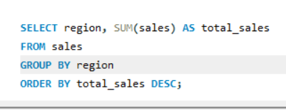
OutPut:
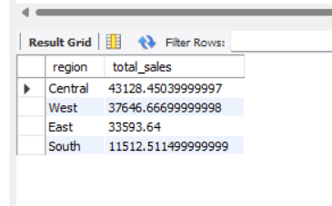

Query 2: Top 5 Profitable Product Categories
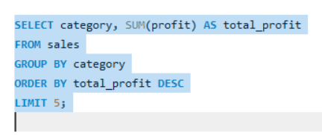
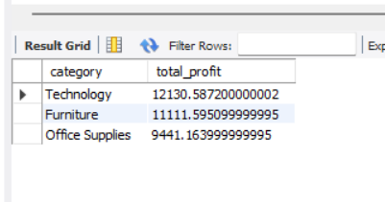
Query 3: Discount Impact Analysis
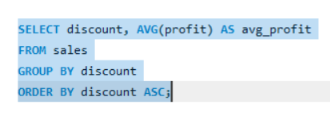
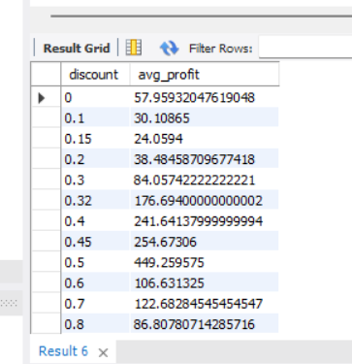

5. Interactive Business Dashboard
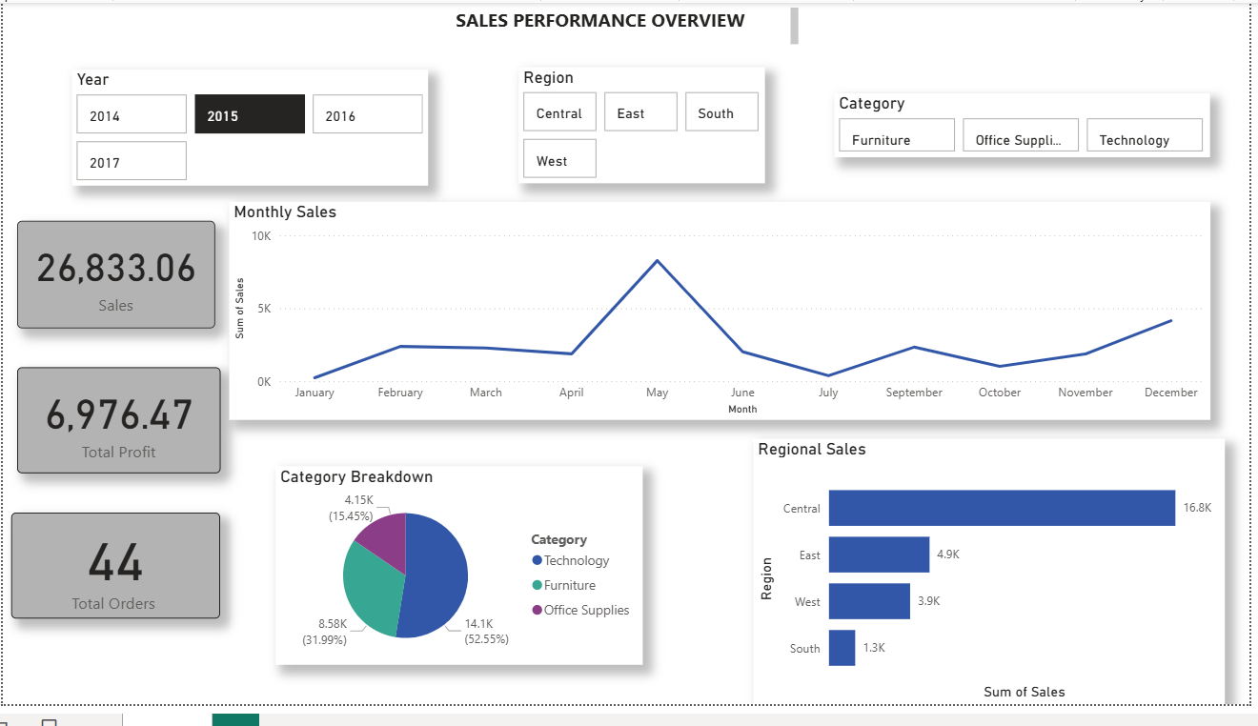

5. Excel Charts

